Jenkins 03
Job1 & 2 We will create one Jenkins Pipeline job with exactly 3 stages:
GitHub
↓
Stage 1: Git Clone
↓
Stage 2: SonarQube Analysis
↓
Stage 3: Slack Notification
Repository:
https://github.com/betawins/VProfile-1.git

Step 1: Check Prerequisites
On the Jenkins server, check:
java -version
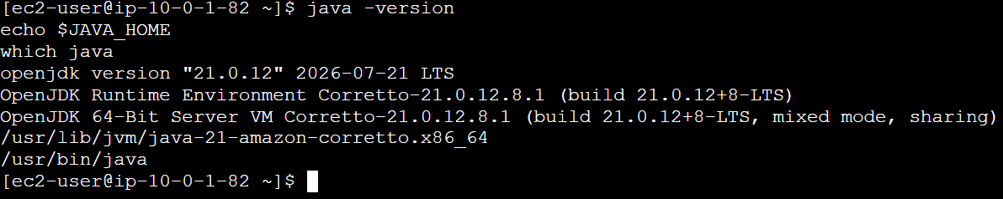
Step 2 — Install required packages
Run:
sudo dnf install wget unzip -y
Verify:
wget --version
unzip -v

Step 3 — Create SonarQube user
Run:
sudo useradd -m -d /opt/sonarqube -s /bin/bash sonar
Check:
id sonar
You should see something similar to:
uid=... (sonar) gid=... (sonar) groups=... (sonar)
Step 4 — Download SonarQube
1 — Create a download directory
mkdir -p ~/sonarqube-download
2 — Go there
cd ~/sonarqube-download
Check where you are:
pwd
You should see:
/home/ec2-user/sonarqube-download
3 — Download SonarQube
wget https://binaries.sonarsource.com/Distribution/sonarqube/sonarqube-26.7.0.124771.zip
Now the 865 MB file will be stored on /, which has approximately 18 GB available.
4 — Verify
ls -lh
You should see approximately:
sonarqube-26.7.0.124771.zip 865M
The official SonarSource download page currently lists Community Build 26.7.0.124771.
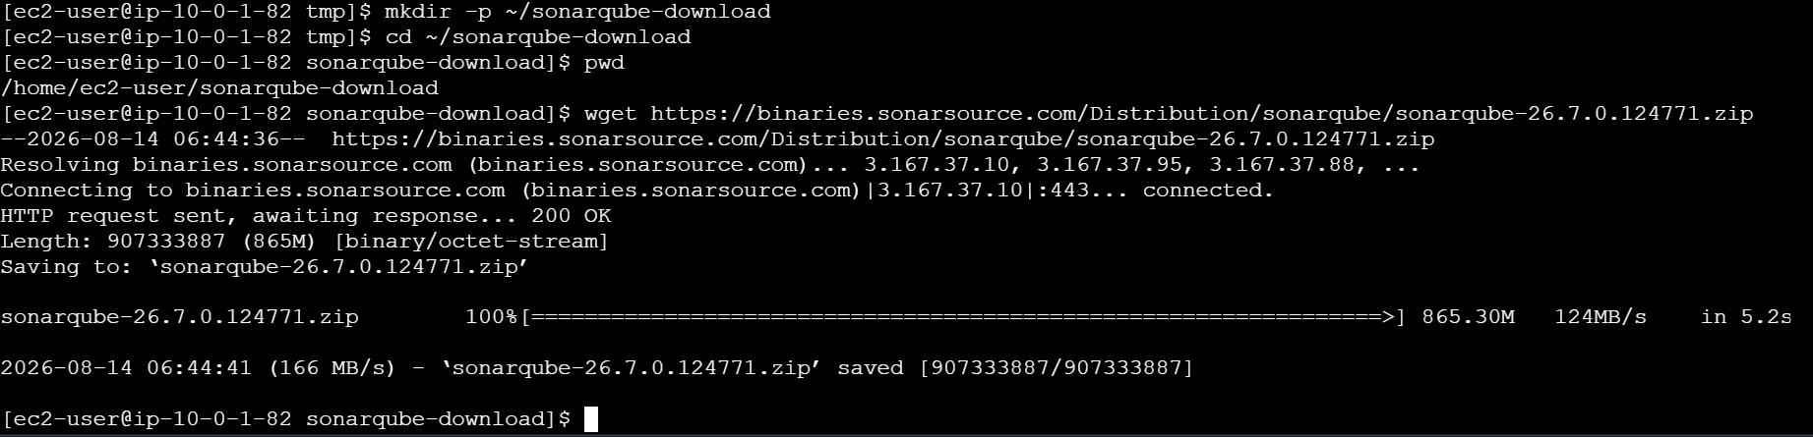
5-Extract SonarQube
You should currently be in:
/home/ec2-user/sonarqube-download
Check:
pwd
ls -lh
Now extract:
sudo unzip sonarqube-26.7.0.124771.zip -d /opt/
This will create:
/opt/sonarqube-26.7.0.124771
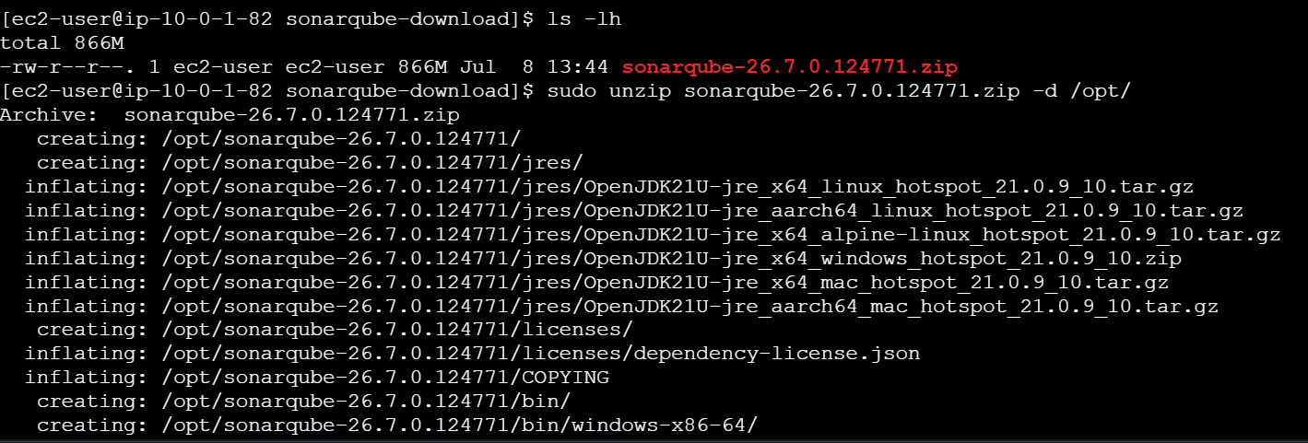

6— Rename the directory
Run:
sudo mv /opt/sonarqube-26.7.0.124771 /opt/sonarqube
Check:
ls -lah /opt/sonarqube
7 — Change ownership
Run:
sudo chown -R sonar:sonar /opt/sonarqube
Verify:
ls -ld /opt/sonarqube
You should see:
sonar sonar ... /opt/sonarqube
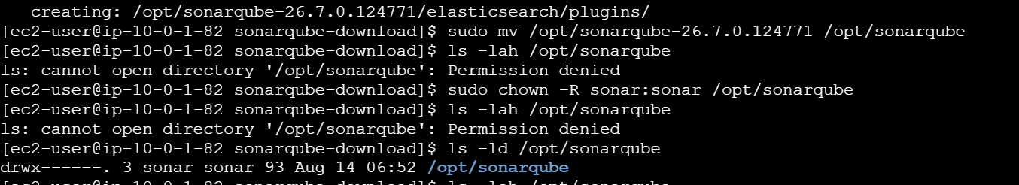

8— Switch to SonarQube user
Run:
sudo su - sonar
Your prompt should become similar to:
[sonar@ip-10-0-1-82 ~]$
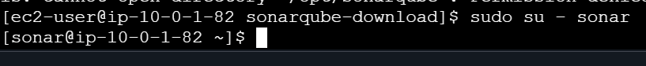
ls -lah /opt/sonarqube
java -version
echo $JAVA_HOME
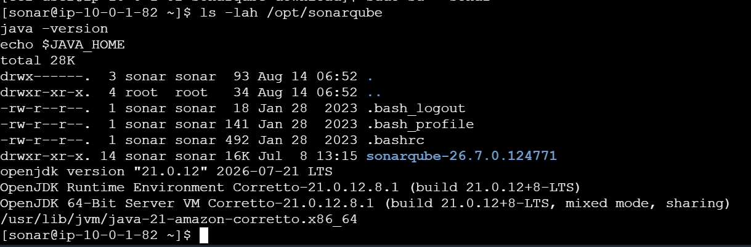
Move SonarQube files
You are already logged in as sonar.
Run:
mv /opt/sonarqube/sonarqube-26.7.0.124771/* /opt/sonarqube/
Also move hidden files if present:
mv /opt/sonarqube/sonarqube-26.7.0.124771/.[!.]* /opt/sonarqube/ 2>/dev/null
Remove the empty directory:
rmdir /opt/sonarqube/sonarqube-26.7.0.124771
Run these three commands
ls -lah /opt/sonarqube
ls -lah /opt/sonarqube/bin/linux-x86-64/
ls -lah /opt/sonarqube/conf/
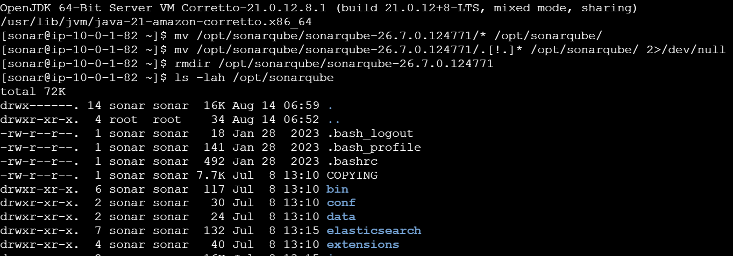
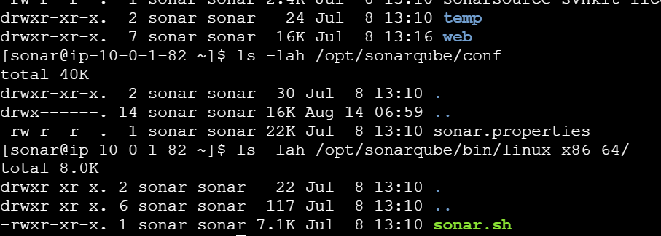
Configure SonarQube port
Open the configuration file:
vi /opt/sonarqube/conf/sonar.properties
Find this line:
#sonar.web.port=9000
Remove # so it becomes:
sonar.web.port=9000
Save and exit:
ESC
:wq
ENTER
You can leave the other settings at their defaults for this lab.
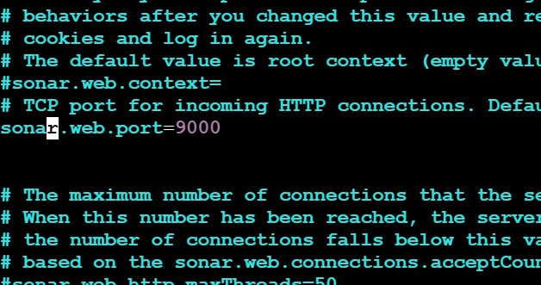

Step 2 — Start SonarQube
You are already logged in as the sonar user.
Run:
/opt/sonarqube/bin/linux-x86-64/sonar.sh start
You should get something similar to:
Starting SonarQube...
Started SonarQube.
/opt/sonarqube/bin/linux-x86-64/sonar.sh status
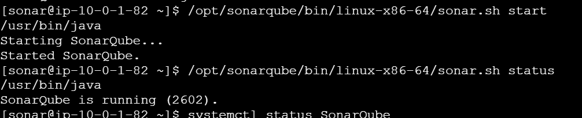
Run: tail -50 /opt/sonarqube/logs/sonar.log
and: tail -50 /opt/sonarqube/logs/web.log
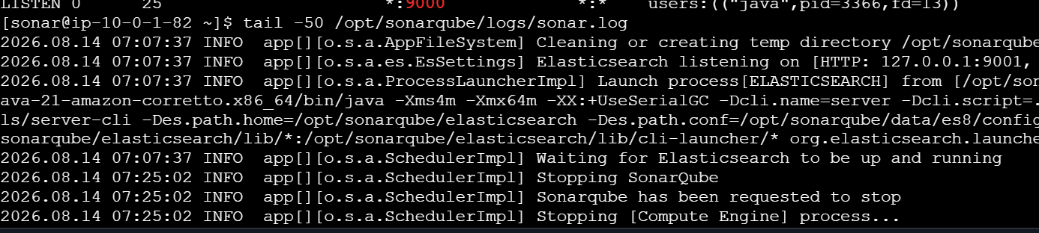
Open SonarQube
In your browser:
http://<SONARQUBE-PUBLIC-IP>:9000
Example:
http://54.xx.xx.xx:9000
http://44.195.92.170:9000

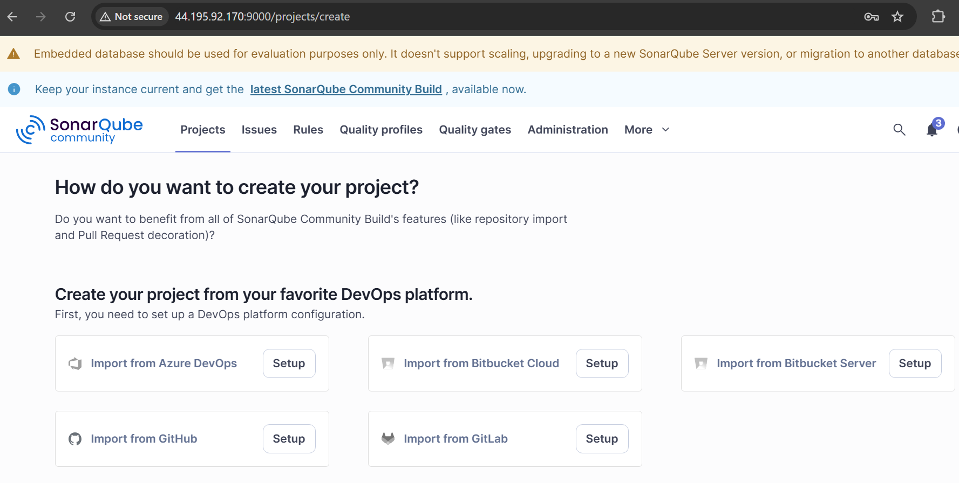

Stage 2 — SonarQube Integration
Step 1 — Create VProfile-1 project
You are currently on the SonarQube page showing:
How do you want to create your project?
Choose the option for local/manual project creation.
Enter: Project display name: VProfile-1
Project key: VProfile-1
Create the project.
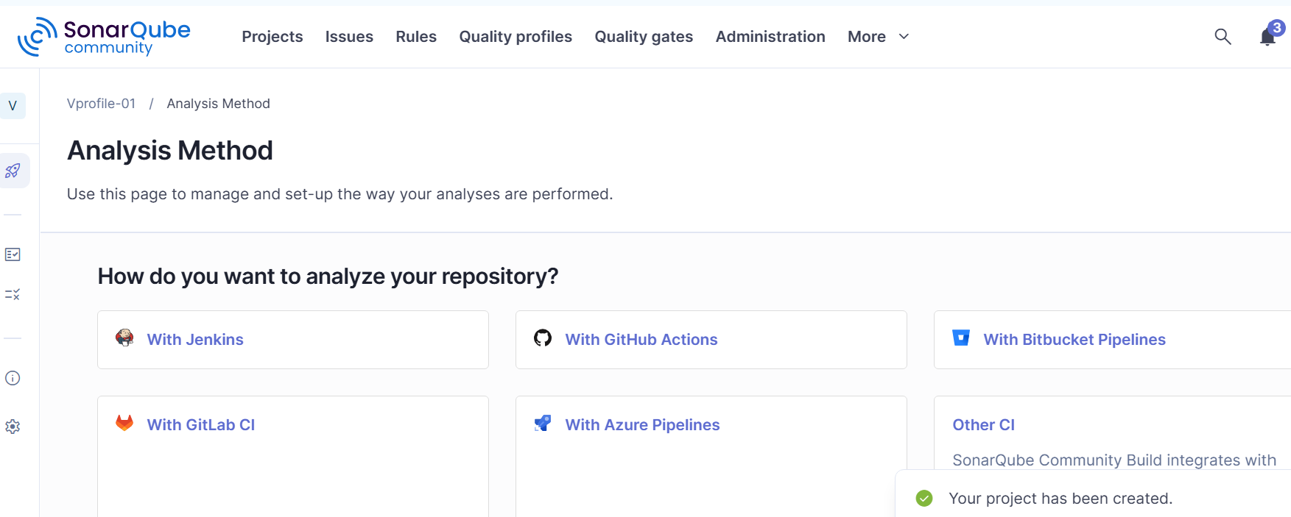

Step 2 — Create SonarQube Token
After creating the project, SonarQube will ask how you want to analyze it.
Choose: Locally
Then select: Maven
Create a token.
Use: Token name: jenkins-vprofile-token
Click Generate.
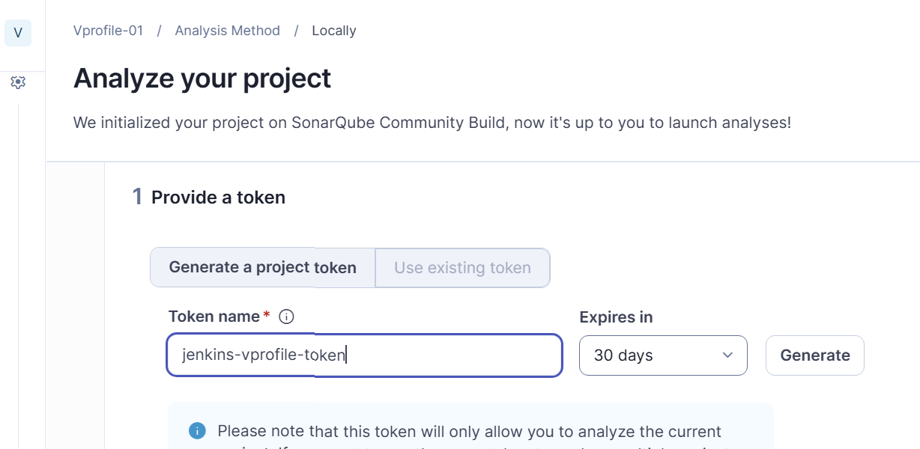
You'll get something similar to:
squ_xxxxxxxxxxxxxxxxx
Copy this token.
Don't send the token to me.
Step 3 — Add Token to Jenkins
Open Jenkins: http://<JENKINS-IP>:8080
Go to: Manage Jenkins
→ Credentials
→ System
→ Global credentials
→ Add Credentials
Select: Kind: Secret text Enter:
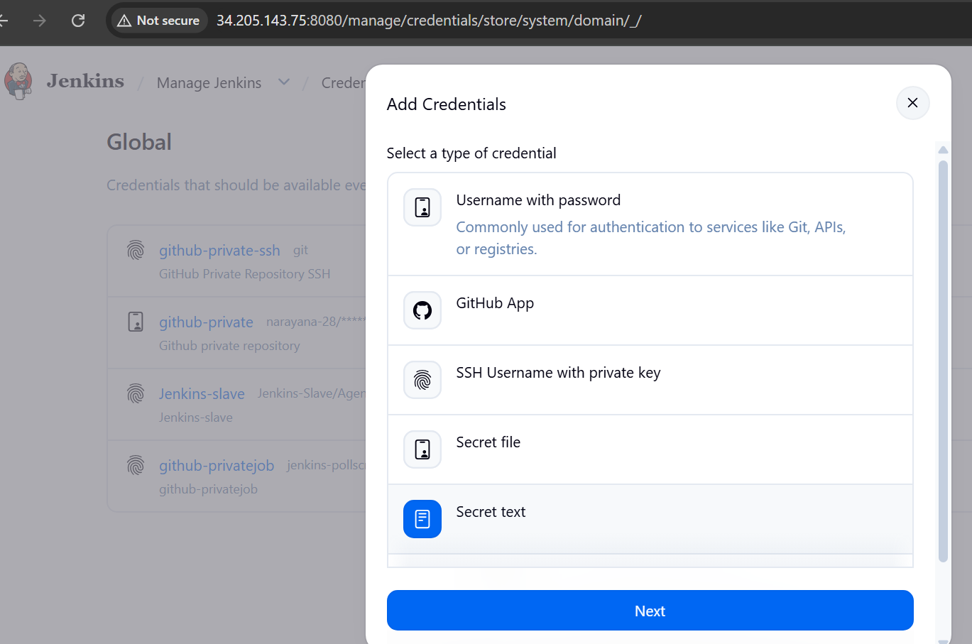
Secret: <YOUR SONARQUBE TOKEN>
ID: sonarqube-token
Click: Create
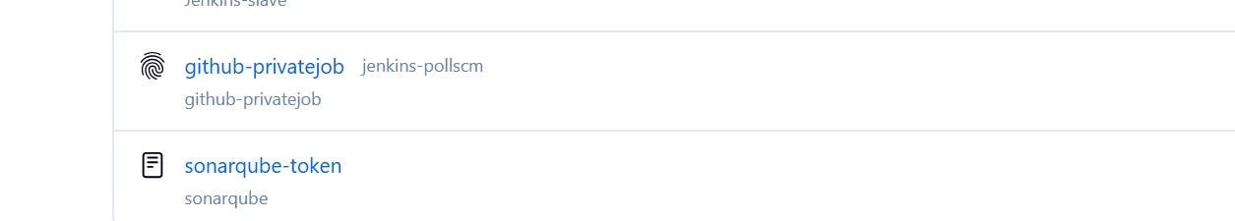
Step 4 — Configure SonarQube Server in Jenkins
Go to: Manage Jenkins → System
Find: SonarQube servers
Click: Add SonarQube
Enter: Name: SonarQube
Server URL: http://44.195.92.170:9000
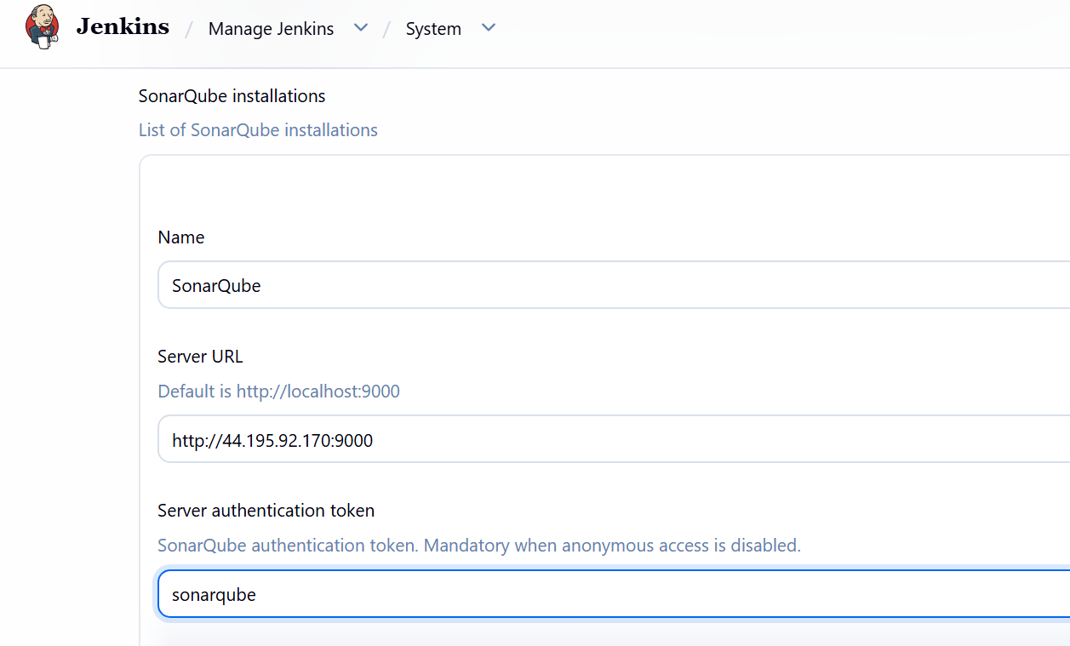
Step 5 — Configure SonarQube Scanner
Go to: Manage Jenkins → Tools
Find: SonarQube Scanner installations
Click: Add SonarQube Scanner
Enter: Name: SonarScanner
Enable: Install automatically
Select the available scanner version.
Click: Save
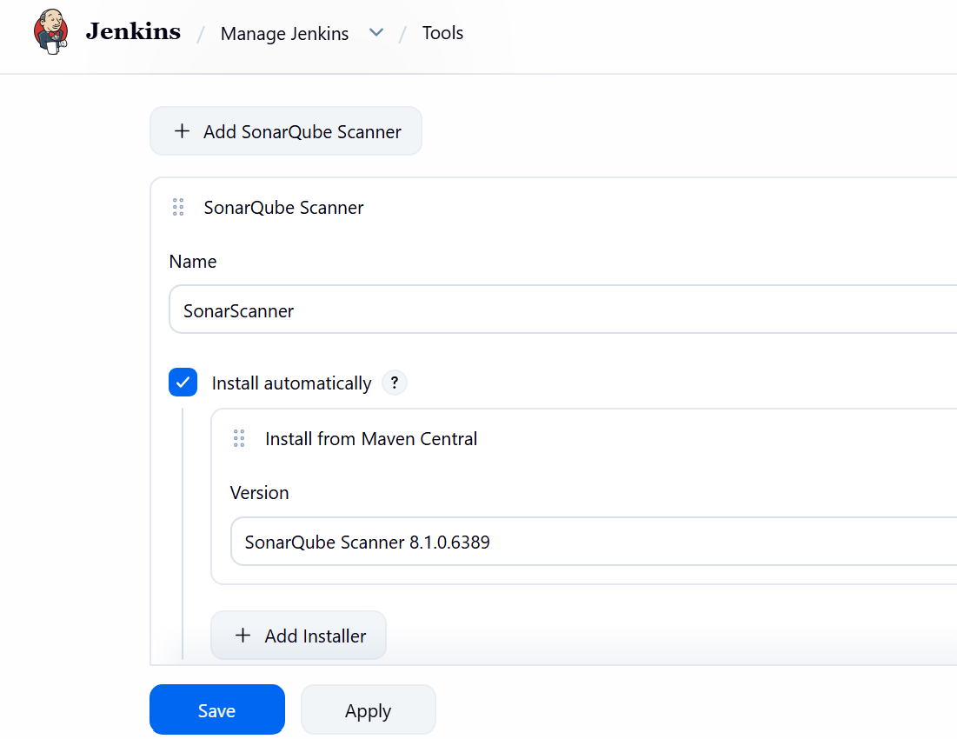
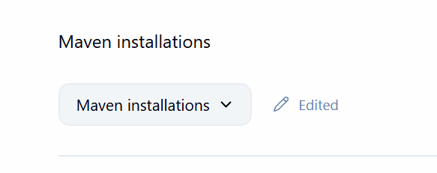
Check Stage 1
Click:
Build #1
→ Console Output
Look for: Cloning the remote Git repository
and: Git Clone Successful
If this succeeds: Stage 1 ✅
Then we'll add Stage 2.
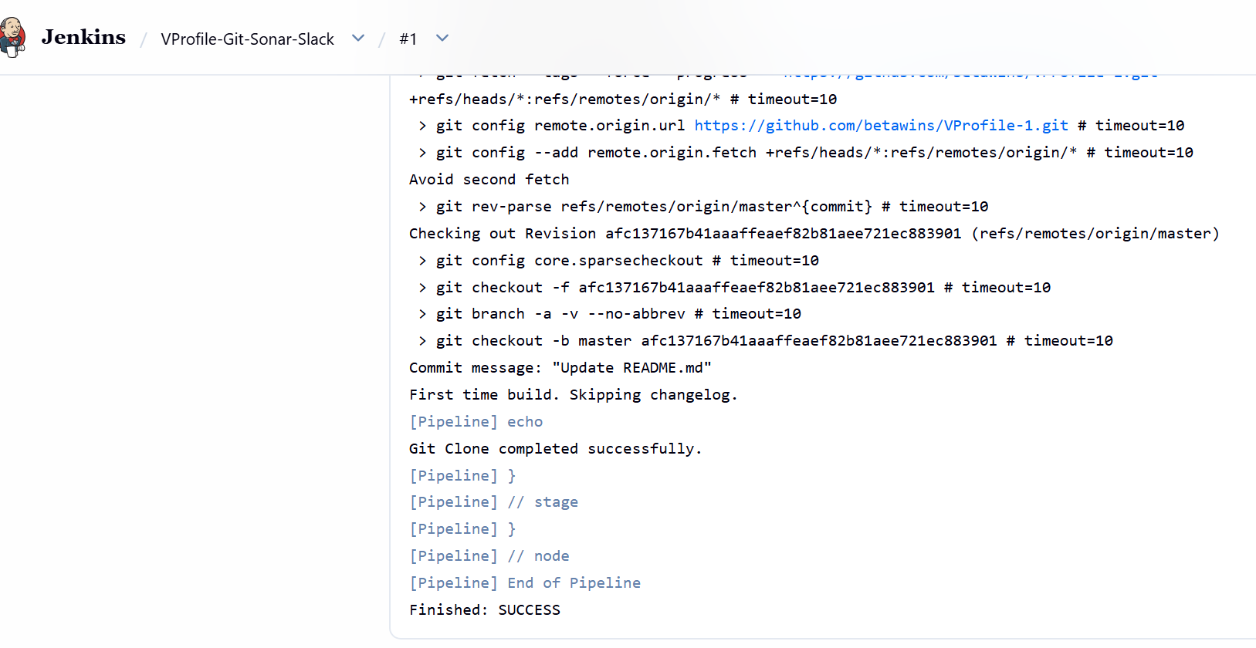

Important: Check the Git Branch
Before running Stage 1, check the repository's default branch.
You can run from your Jenkins server:
git ls-remote --heads https://github.com/betawins/VProfile-1.git
If you see: refs/heads/master
use: git branch: 'master'
If you see: refs/heads/main
use: git branch: 'main'
4. Add Stage 2 to Jenkins Pipeline
Paste this stage into the Pipeline:
stage('SonarQube Integration') {
steps {
echo 'Stage 2: SonarQube Analysis started'

withSonarQubeEnv('SonarQube') {
withCredentials([string(
credentialsId: 'sonarqube-token',
variable: 'SONAR_TOKEN'
)]) {

sh '''
mvn --version

mvn clean verify \
org.sonarsource.scanner.maven:sonar-maven-plugin:sonar \
-Dsonar.projectKey=Vprofile-01 \
-Dsonar.projectName=Vprofile-01 \
-Dsonar.token=$SONAR_TOKEN
'''
}
}

echo 'Stage 2: SonarQube Analysis completed'
}
}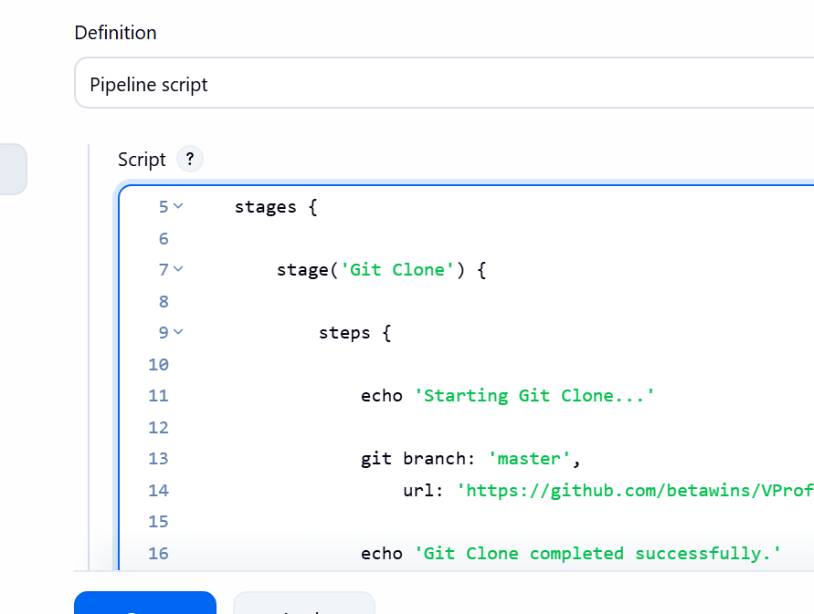

5. Run Jenkins Build
Click:
Build Now → Console Output
Verify:
Stage 2: SonarQube Analysis started
Apache Maven 3.9.16
...
BUILD SUCCESS
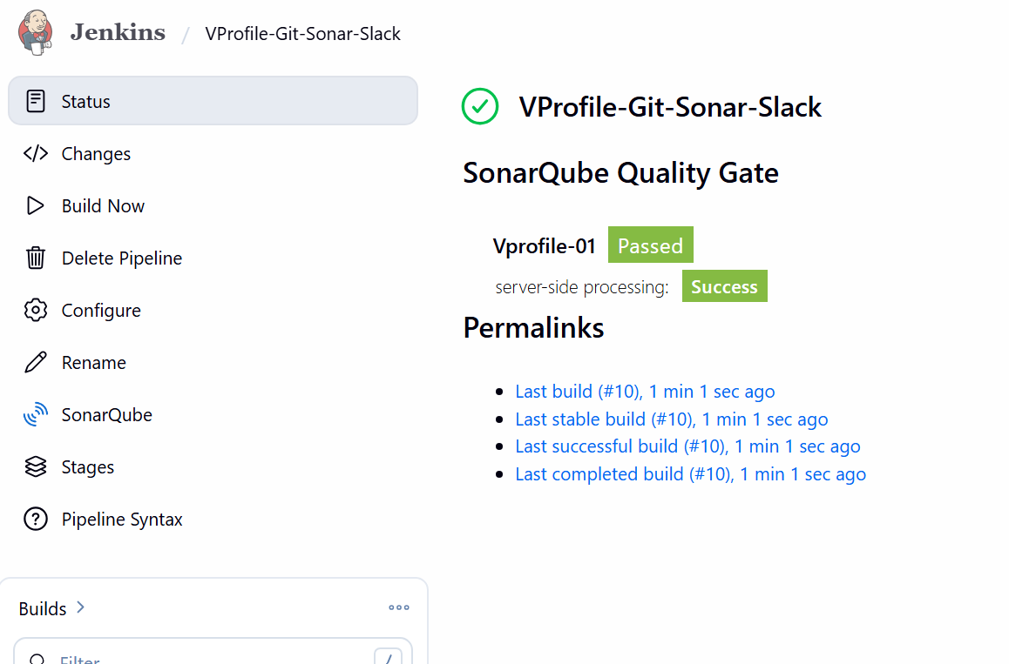

6. Verify SonarQube
Open:
SonarQube → Projects → Vprofile-01
Verify that the analysis results are displayed.
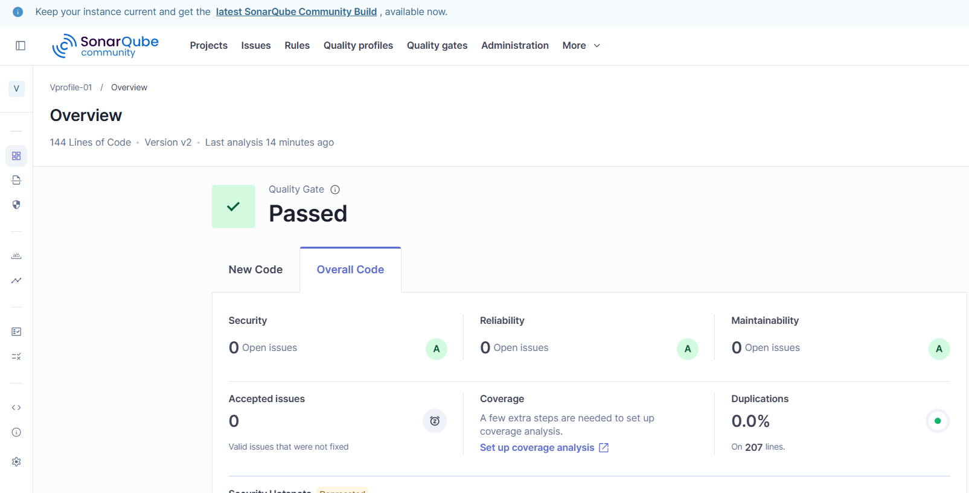

Stage 3: Slack Integration
We will configure Jenkins to send a Slack notification after the pipeline finishes.
Step 1: Create/prepare Slack
- Open your Slack workspace.
- Create a channel for Jenkins notifications, for example:
#jenkins-notifications
- Make sure you have permission to add/install the Jenkins integration
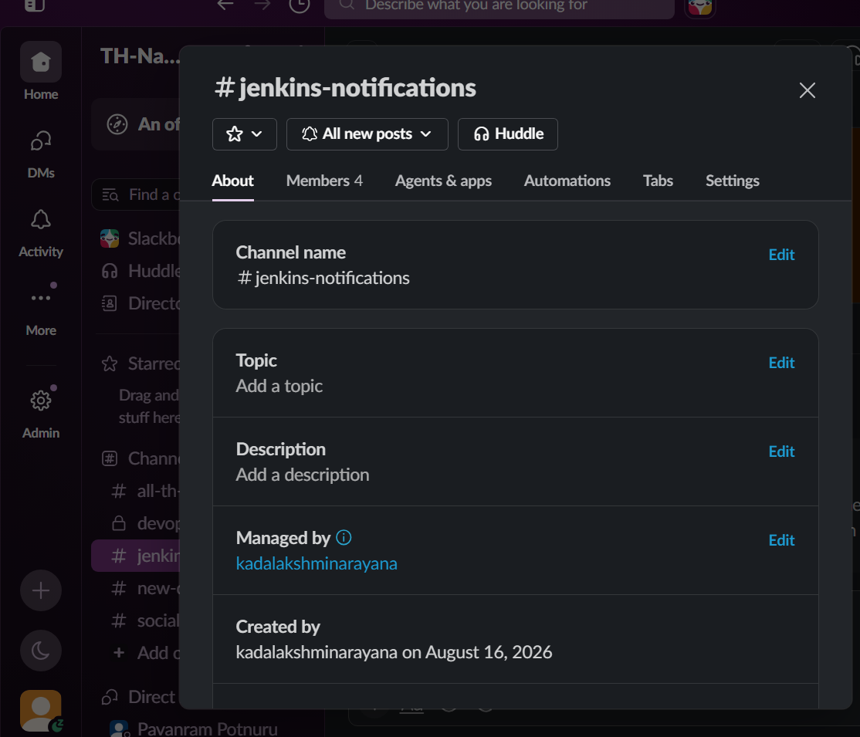

Step 2: Install Jenkins Slack Notification Plugin
In Jenkins:
Manage Jenkins → Plugins → Available plugins
Search:
Slack Notification
Install the Slack Notification Plugin.
If Jenkins asks for a restart, restart Jenkins. 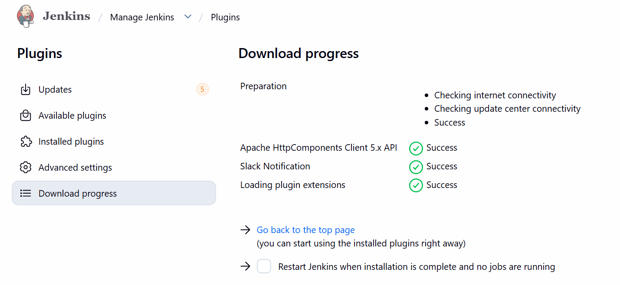
Step 3: Configure Slack in Jenkins
Go to:
Manage Jenkins → System
Find:
Global Slack Notifier Settings
Configure your Slack workspace/integration according to the credentials provided by your Slack app/integration.
Typically you will configure:
Workspace / Team Domain
Credential
Default Channel
For the credential, store the Slack token securely in:
Jenkins → Credentials → Global → Add Credentials
Use:
Kind: Secret text
ID: slack-token
Secret: <your Slack token>
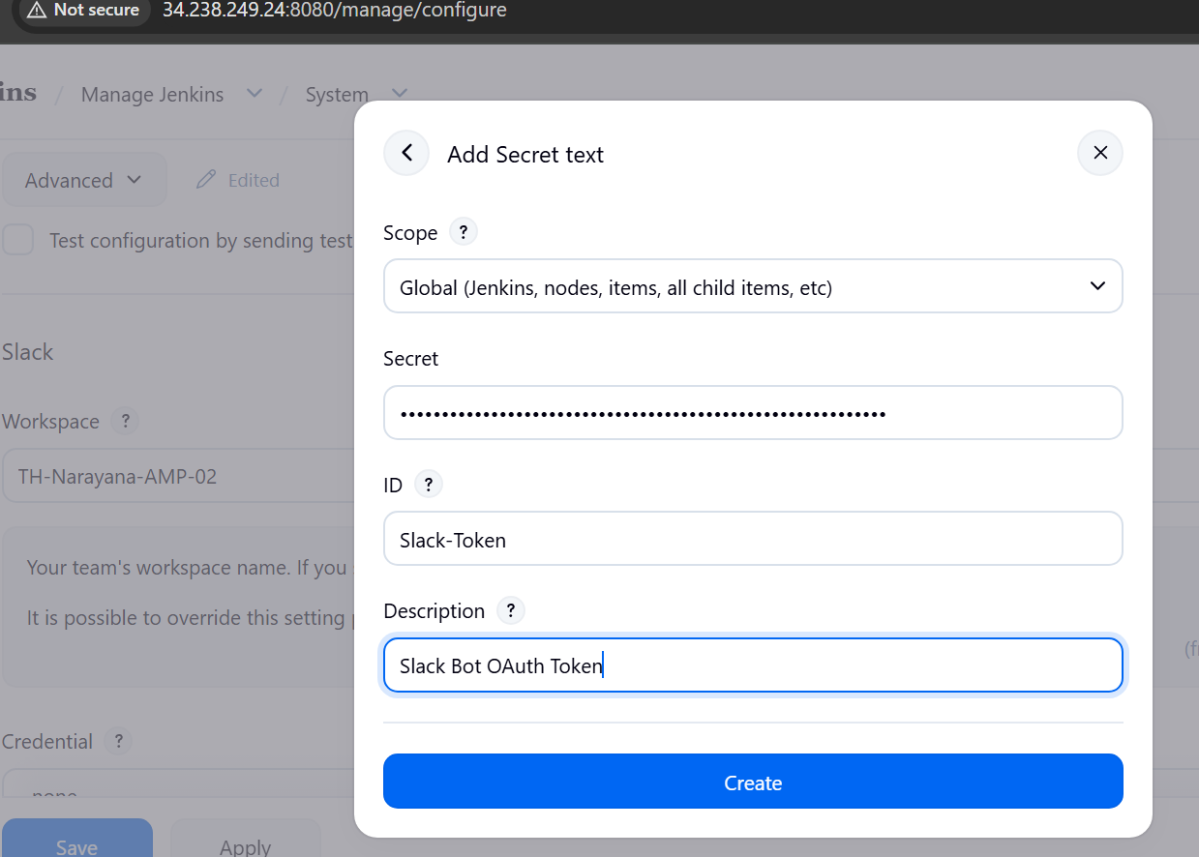
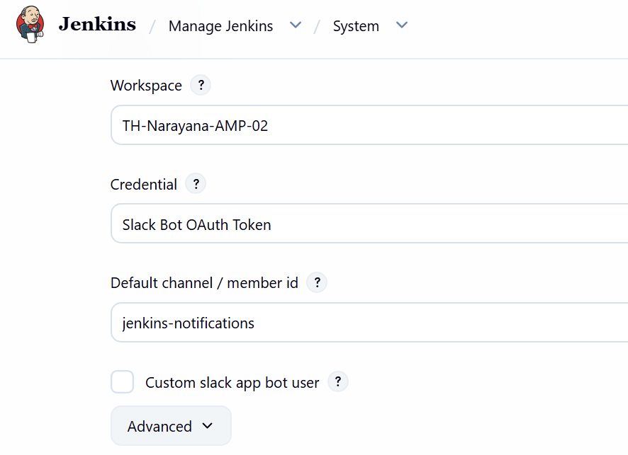

Step 4: Add Stage 3 to Pipeline
Add this after the SonarQube stage:
stage('Slack Integration') {
steps {
echo 'Stage 3: Slack Integration started'

slackSend(
channel: '#jenkins-notifications',
message: "Jenkins Build SUCCESS: ${env.JOB_NAME} #${env.BUILD_NUMBER}\nSonarQube Quality Gate: PASSED"
)

echo 'Stage 3: Slack Integration completed'
}
}
Your pipeline will now have:
Stage 1 → Git Clone
↓
Stage 2 → SonarQube Analysis
↓
Stage 3 → Slack Notification
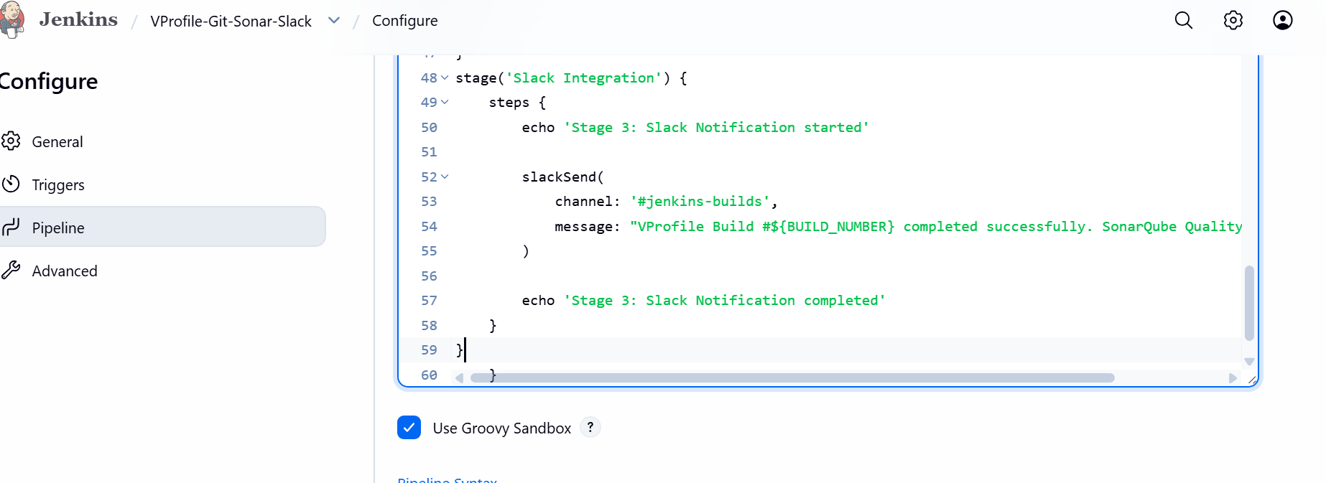

Step 5: Save and Build
Go to:
Jenkins → VProfile-Git-Sonar-Slack → Build Now
Open:
Console Output
You should see:
Stage 1: Git Clone completed
then:
Stage 2: SonarQube Analysis completed
then:
Stage 3: Slack Integration started
and finally:
Stage 3: Slack Integration completed
Finished: SUCCESS
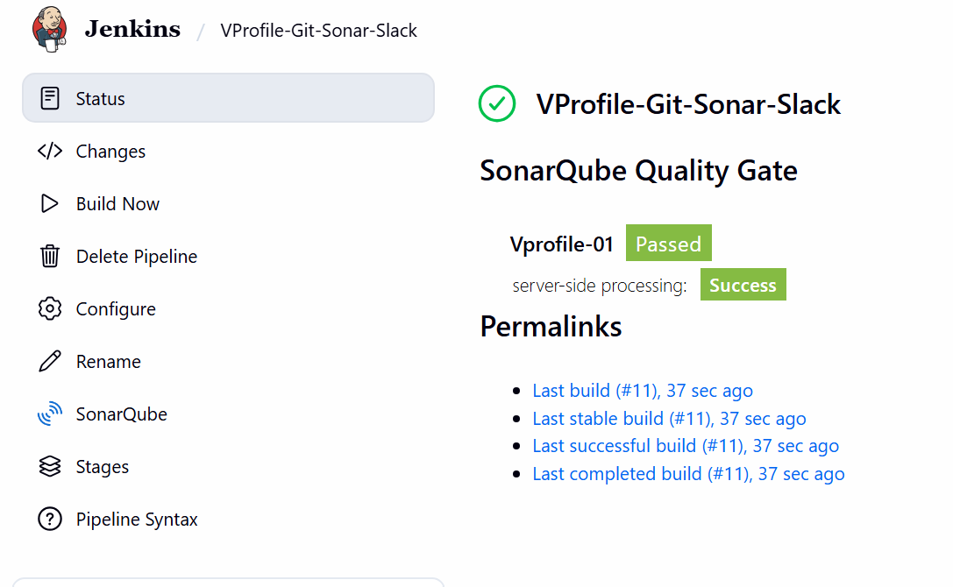
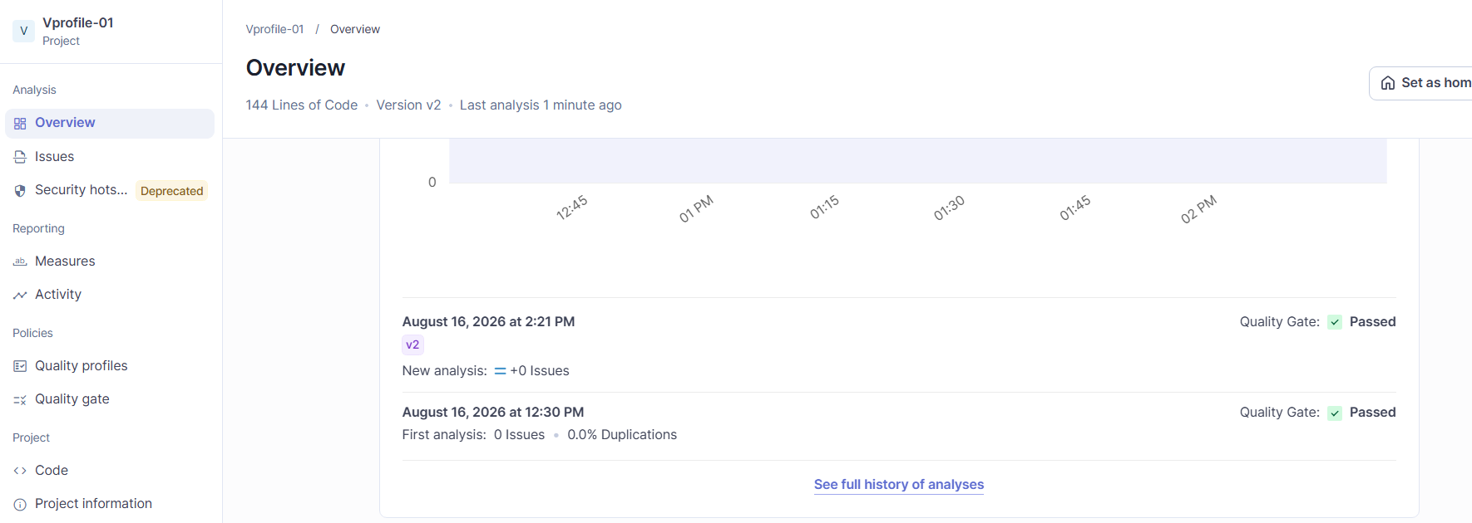

Step 6: Verify Slack
Open:
#jenkins-notifications
You should receive a message similar to:
Jenkins Build SUCCESS: VProfile-Git-Sonar-Slack #10
SonarQube Quality Gate: PASSED
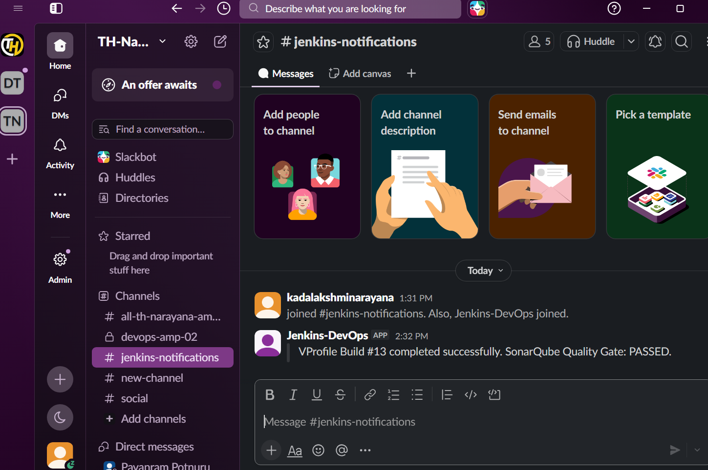
Jenkins Job 2 — Hiring App
Objective
Create one Jenkins Pipeline job with exactly 3 stages:
GitHub
↓
Stage 1: Git Clone
↓
Stage 2: SonarQube Integration
↓
Stage 3: Slack Integration
Source repository:
https://github.com/narayana-28/hiring-app
Step 1: Create the Jenkins Job
Go to:
Jenkins → New Item
Enter:
Name: Hiring-App-Git-Sonar-Slack
Select:
Pipeline
Click OK.

Step 2: Pipeline Configuration
Scroll down to Pipeline.
Select:
Definition: Pipeline script
Paste this code:
pipeline {

agent any

tools {
maven 'Maven'
}

stages {

stage('Git Clone') {
steps {
echo 'Stage 1: Git Clone started'

git branch: 'main',
url: 'https://github.com/narayana-28/hiring-app.git'

echo 'Stage 1: Git Clone completed'
}
}

stage('SonarQube Integration') {
steps {
echo 'Stage 2: SonarQube Analysis started'

withSonarQubeEnv('SonarQube') {
sh '''
mvn --version

mvn clean verify \
org.sonarsource.scanner.maven:sonar-maven-plugin:5.7.0.6970:sonar \
-Dsonar.projectKey=Hiring-App \
-Dsonar.projectName=Hiring-App
'''
}

echo 'Stage 2: SonarQube Analysis completed'
}
}

stage('Slack Integration') {
steps {
echo 'Stage 3: Slack Notification started'

slackSend(
channel: '#jenkins-builds',
color: 'good',
tokenCredentialId: 'Slack-Token',
message: """Hiring-App Build Successful

Job: ${env.JOB_NAME}
Build: #${env.BUILD_NUMBER}
Status: ${currentBuild.currentResult}
SonarQube: Analysis Completed
Jenkins: ${env.BUILD_URL}
"""
)

echo 'Stage 3: Slack Notification completed'
}
}
}

post {
failure {
slackSend(
channel: '#jenkins-builds',
color: 'danger',
tokenCredentialId: 'Slack-Token',
message: """Hiring-App Build FAILED

Job: ${env.JOB_NAME}
Build: #${env.BUILD_NUMBER}
Status: ${currentBuild.currentResult}
Jenkins: ${env.BUILD_URL}
"""
)
}
}
}
Click Save.
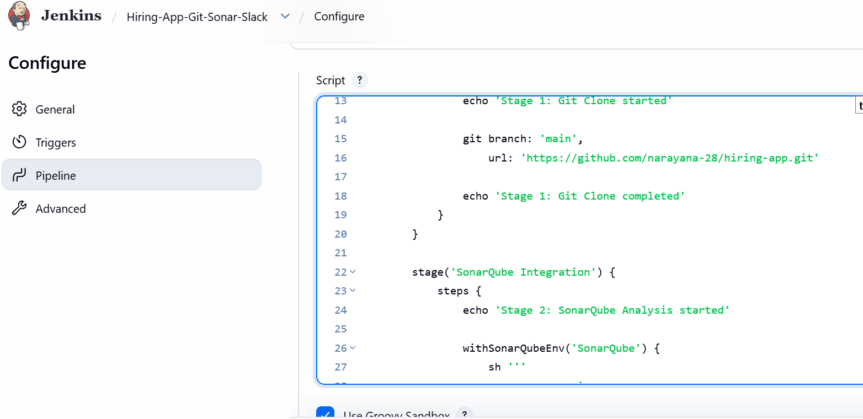

Step 3: Verify Jenkins Tools
Because your previous job is already working, you should already have:
Maven
Manage Jenkins → Tools → Maven installations
Name: Maven
Install automatically: ✓
Version: 3.9.16
SonarQube Scanner
Your previous setup already has the SonarQube configuration:
Name: SonarQube
And under:
Manage Jenkins → System → SonarQube installations
you should have:
Name: SonarQube
Server URL: http://32.197.191.102:9000/
Slack Credential
You already created:
ID: Slack-Token
Type: Secret text
So we can reuse it.
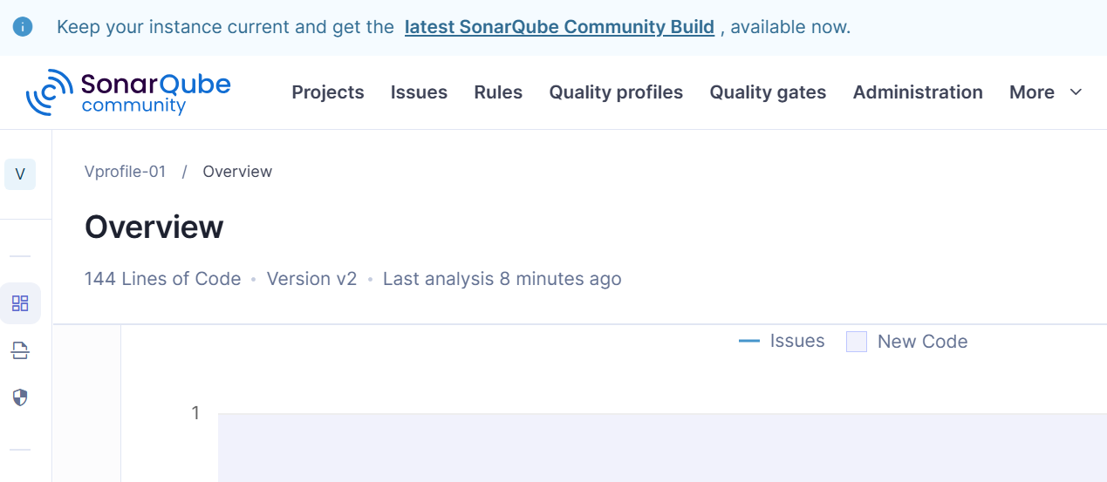
Step 4: Important — Check the Hiring-App Project Type
Before running the job, open the repository and check whether it contains:
pom.xml
If it contains pom.xml, the Maven pipeline above is appropriate.
If it doesn't contain pom.xml, don't run the Stage 2 Maven command yet. The SonarQube analysis command needs to match the project's build technology.
Step 5: Run the Job
Go to: Hiring-App-Git-Sonar-Slack → Build Now
Open: Build #1 → Console Output
Stage 1 should show:
Stage 1: Git Clone started
...
Stage 1: Git Clone completed
Stage 2 should show: Stage 2: SonarQube Analysis started
Apache Maven 3.9.16
BUILD SUCCESS
Stage 2: SonarQube Analysis completed
Then check SonarQube for the project: Hiring-App
Stage 3 should show: Stage 3: Slack Notification started
[Pipeline] slack Send
Stage 3: Slack Notification completed
Finished: SUCCESS
And Slack should receive:
Hiring-App Build #1 completed successfully.
SonarQube Analysis: PASSED.
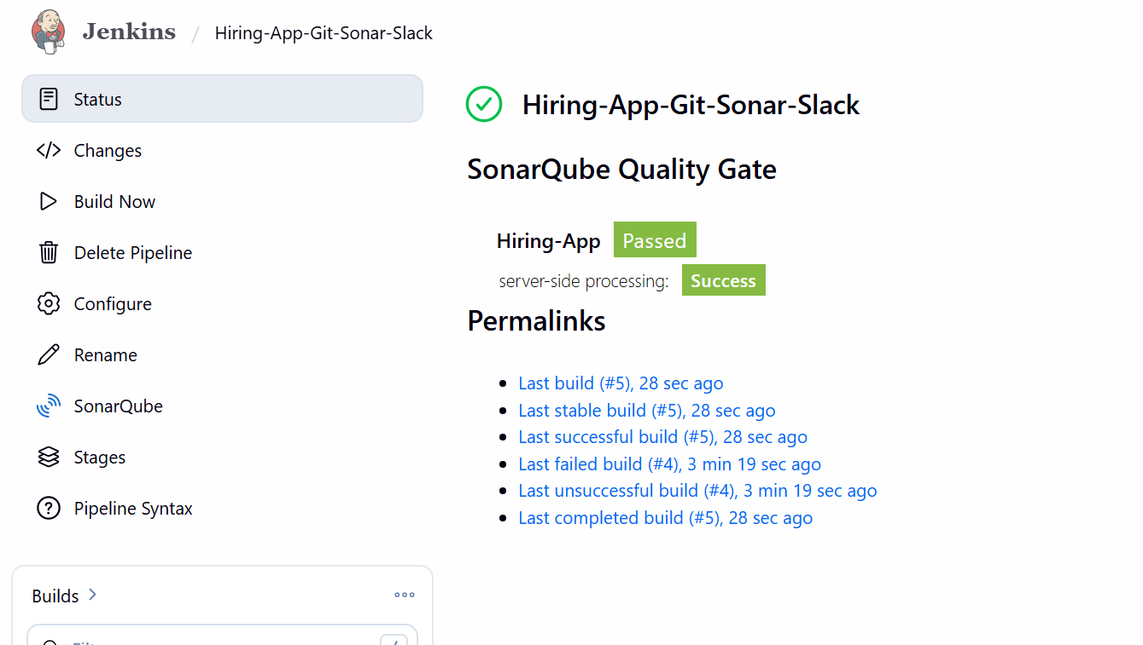
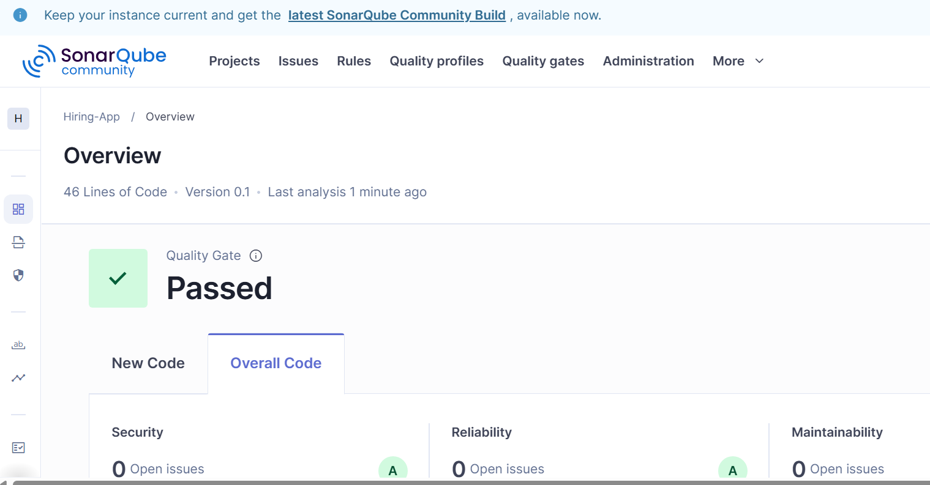
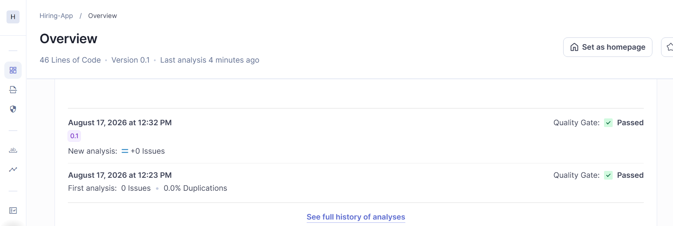

Capture these for Job 2:
- Jenkins job configuration
- Pipeline code showing the 3 stages
- Stage 1 Git clone successful
- Stage 2 Maven/SonarQube successful
- Hiring-App SonarQube dashboard
- Stage 3 Slack notification successful
- Slack #jenkins-builds notification
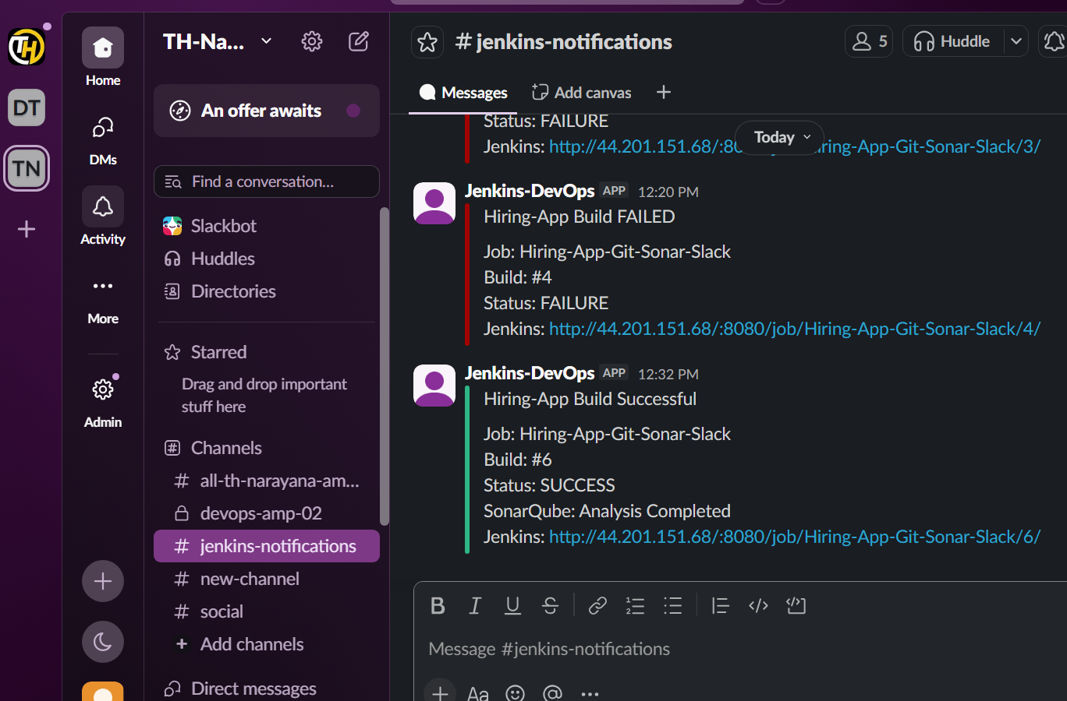
Final architecture
GitHub
│
│ Clone
▼
┌──────────────────┐
│ Stage 1 │
│ Git Clone │
└────────┬─────────┘
│
▼
┌──────────────────┐
│ Stage 2 │
│ Maven + SonarQube │
└────────┬─────────┘
│
▼
┌──────────────────┐
│ Stage 3 │
│ Slack Notification│
└────────┬─────────┘
│
▼
#jenkins-notifications

